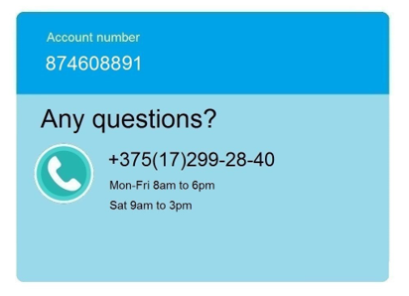**Bill date:** {{datain}}

**Bill number:** 68521014985/2

This is a VAT invoice



{{surnameadt}} {{nameadt}}

Belarus, {{address}}

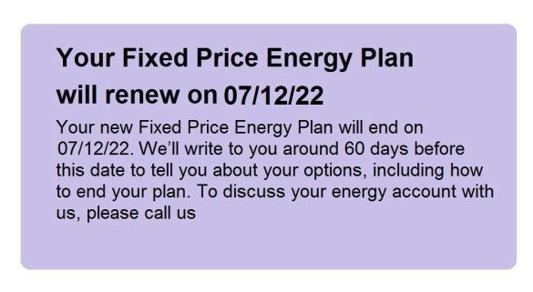Your electricity bill

{{datapre}} – {{datain}}

 **{{dataposle}}**

**{{dataposle}}.**





Your account

|  |  |
| --- | --- |
| Since your previous bill |  |
| Outstanding balance | 127,25 |
| Cheque received | 127,25 |
| **Balance from last bill** | **0,00** |

**New charges this bill (see over for details)**

|  |  |
| --- | --- |
| Electricity charges | 104,28 |
| Standing charges | 21,41 |
| **Total charges exc VAT** | 137,75 |
| VAT | 4,07 |
| **Total new charges this bill inc VAT** | **{{allsum}}** |



**Total amount now due {{allsum}} BYN**

Please pay this by {{dataposlep}}



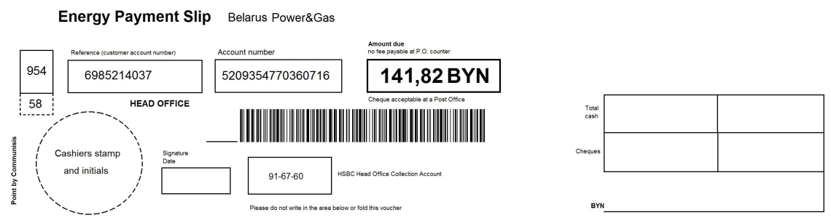

|  |  |  |
| --- | --- | --- |
| {{accnum}} |  | {{allsum}} BYN |

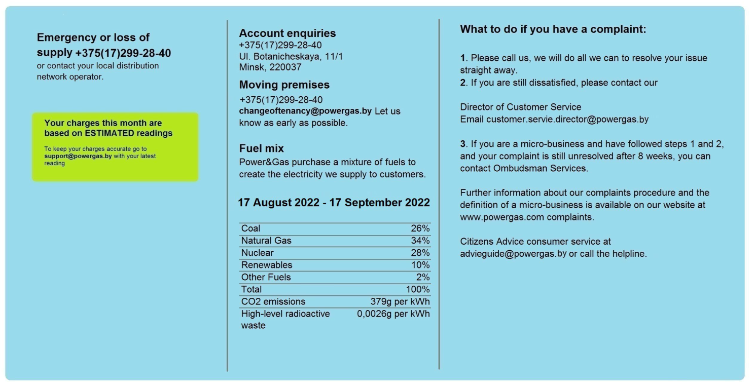



**{{datapre}} – {{datain}}**

Details of charged

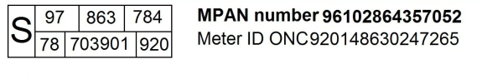

|  |  |  |  |  |  |
| --- | --- | --- | --- | --- | --- |
| *Previous reading* | *Current reading* | *Multiplier* | *kWh* | *Rate* | *Charges* |
| **Night unit charge**  3659 ESTIMATED | 3764 READ | 47 units x 2.0 | 136 | 3.154 | 116,06 |
| 3764 READ | **3893 ESTIMATED** | 4 units x 2.0 | 6 | 3.154 | 4,47 |
| **Day unit charge** 54621  ESTIMATED | 54769 READ |  | 293 | 6.547 | 2,38 |
| 54769 READ | 54871 **ESTIMATED** |  | 26 | 6.547 | 5,66 |
| **Electricity charges** |  |  |  |  | **139,97** |
| Standing sharge |  | 23 days at 32.478 |  |  | 4,28 |
| **Total charges** exc VAT |  |  |  |  | **137,75** |
| VAT at 5% |  |  |  |  | 4,07 |
| **Total charges** inc VAT |  |  |  |  | **{{allsum}} BYN** |



